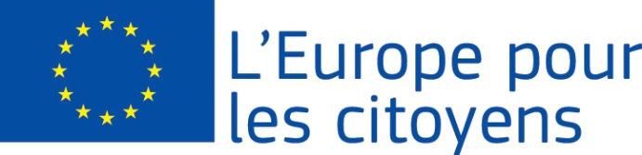
Europe for Citizens

The project «Plus European Citizenship- Less Euroscepticism» was funded with the support of the European Union under the Programme « Europe for Citizens»
Strand 2 Measure 2.1 “Town Twinning”
Partecipation: The project was implemented by 120 participants. Fifty-six citizens from Oravská Polhora (Slovakia) were hosted in Colliano (ITALY) for three days to talk about the European Union.

Venue/Date: the meeting took place in Colliano (ITALY) from 10 to 12 August, 2019

Short description:
To tackle the advance of Euroscepticism in small rural centers, strengthening the sense of belonging to the EU, knowing the rights deriving from the European citizenship, creating a close link between citizens and Union, represented the biggest challenge for the project.
The objective was achieved through:
1) the dissemination of tools to actively participate in the democratic life of the EU;
2) understanding the Union and its functioning;
3) increasing awareness of the rights deriving from European citizenship.
The indicator for assessing the degree of objectives achievement is derived from the visit made by 5 citizens of Colliano (Italy) to Oravská Polhora (Slovakia) in September 2019.
After the notification by EACEA of the selection and co-financing of the project "Plus European Citizenship-Less Euroscepticism" in mid-June, the staff of the two Municipalities immediately started to work for the perfect implementation of the project and its activities. We carried out surveys within the two communities on the degrees of knowledge of the rights deriving from European citizenship and the degree of widespread Euroscepticism, bearing in mind also the results of the European Parliament elections. A considerable distance has emerged between citizens and the Union; a cultural autarchy, due to the strong traditions that connect the citizen to their territory.
Defined journey, hotel and food, 56 Slovak citizens left on 9 August to travel 1800 kilometers and reach Colliano.
On the afternoon of 10 August, after a brief greeting from the two mayors, all the activities of the event were presented.
On 11 August, in the morning, the mayors of the two cities gave life to the official twinning ceremony, recalling that this instrument was born to strengthen peace between peoples, preceded by a brief presentation of the Programme "Europe for Citizens" and sub-measure " Town Twinning ”. Then, there was the symbolic exchange of the keys of the cities, the signing of the twinning oath, the exchange of gifts and the inauguration of the table at the entrance of the Municipality of Colliano: "Città di Colliano gemellata Oravská Polhora (Slovakia)".
After the official twinning ceremony, the journalist Margherita Siani moderated the conference on European citizenship, highlighting the rights that derive from it, showing the Union's web sites that illustrate this theme. The participants presented analyzes and reflections on the European identity and on the feeling of belonging to the Union in their communities. The presentations were supported by previously prepared slides.

The intense activities of the day culminated in a popular intercultural festival, in which Italian and Slovak musicians played bagpipes together, with traditional sounds and songs, in the streets of the City. The masters have shown and explained how this ancient and noble instrument is played. Legends have been retraced, tales of tradition, folk songs, dialectal poems and proverbs that link the bagpipe to the cultural heritage of the two cities. This allowed an intensive exchange and intercultural dialogue.

On the morning of 12 August, before the guests' departure, we planned future cooperation activities in the European field. A delegation of Colliano citizens was invited from 12 to 15 September 2019 to Oravská Polhora (Slovakia). The staff of the Municipalities have planned to participate in other calls foreseen by the European Union, in particular "Networks of Towns" and the Programme “Creative Europe”.

